CSE220: Data Structures (Lab)

Fall 2024

Lab Quiz - 05

Duration: 30 Minutes

| Name: | ID: | Section: |
| --- | --- | --- |

### **Question 1 [15 Points]**

In this task you will be given the root node of a binary search tree. You need to calculate the **sum** of the values of the nodes that are **mirrors** of each other. Here, mirror means the nodes that are located in **corresponding positions in the left and right subtrees**. You need to define the **Node class** for Binary Tree. You can use **helper functions**.

**Example Tree input 1**   **Example Tree input 2**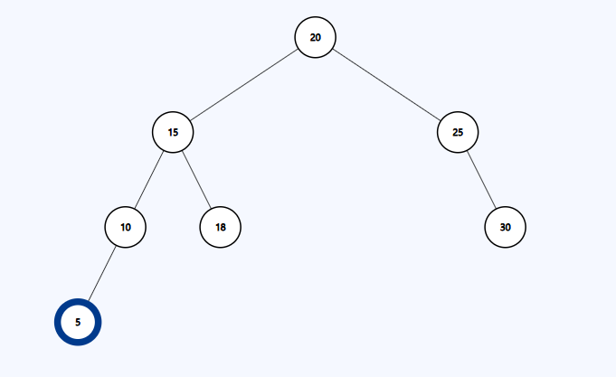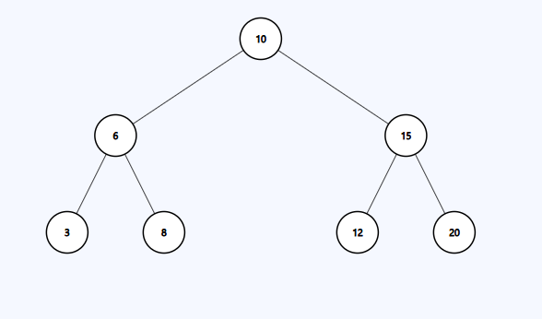

| **Sample Input** | **Sample Output** | **Explanation** |
| --- | --- | --- |
| mirror(root) | 64 | For Tree 1 Mirror nodes are:  6 and 15, sum = 6 + 15 = 21  3 and 20, sum = 3 + 20 = 23  8 and 12, sum = 8 + 12 = 20  Total Mirror Node Sum = 21 23 20 = 64 |
| mirror(root) | 80 | For Tree 2 Mirror nodes are:  15 and 25, sum = 15 + 25 = 40  10 and 30, sum = 10 +30 = 40  Total Mirror Node Sum = 40 + 40 = 80 |